# Introduction

Welcome to the NYMTC Transportation Information Gateway (the Gateway).

This is a tool designed to house and visualize various datasets useful for collaborative planning. It contains an array of useful features, which are described in the following document.

If you click the "?" icon on any page, you will be directed to a specific place in this document that will give you contextually-appropriate explanations and guidance as to the features on that page.

# User Accounts

## Sign Up

Please enter information as completely as possible. Asterisked fields are required.

If you've forgotten your password, please click the "Forgot your password?" button, and see Password Reset.

## Sign In

Enter your username and password to log in to the Gateway. You may click "Remember Me" to be automatically signed in when you visit the Gateway website in the future. If you do not have an account on the Gateway, see Sign Up. If you've forgotten your password, see Password Reset.

If you're a public user and do not have an account, you may still be able to see some data sources. However, you will have access to more Sources and Views if you register for an account.

## Password reset

If you have forgotten your password, click the 'Forgot your password?' button, located in the Sign In screen.

Enter the email address you used to sign up for the Gateway, and hit send. The Gateway will send you an email with directions to reset your password.

System and Agency Administrators can also aid you in resetting a password.

# Dashboard

## Overview

Upon logging into the Gateway, you'll see a variety of panes. The Catalog Summary will contain an abbreviated list of the sources and views you have permission to see. Recent Activity will show you a list of recent actions taken by Gateway users. For Administrators, New Contributions will show Sources and Views that have been created or updated recently. My Snapshots will show a list of the sources and views for which you've created a Snapshot.

In the header, on the right, there will also be a menu with various options. Clicking your name will display a list of options for customization. If you're an admin, contributor, or librarian, there will be options there for you as well. See **My Pages** for more information on these options.

At any point you can return to the dashboard by clicking the NYMTC Gateway Logo or clicking the "Dashboard" button at the far left of the breadcrumbs menu.

## Navigation

The dashboard is an overview of the content in the Gateway. Clicking on the title of any individual pane will show you more information about that subsection.

# Catalog

The Catalog is a collection of all the views and sources in the Gateway. It is found on the Dashboard and can be expanded by clicking either Catalog in its title or clicking the "show more" button at the bottom.

Clicking a source will expand all the views available for each source. Clicking on a view will display that view's associated actions in the sidebar next to the view. Different user privileges will see different actions. For the typical user, when available based on data set type, Maps, Tables, Charts, and Metadata will be available.

The Catalog can also be listed in Table Format.

There are several icons associated with sources and views:

If you see a chat bubble icon with a number in it next to a source or view, that means users have commented on that source or view.

An eye next to a source or view means you're Watching that item and have additional options.

A cloud icon next to a source or view means you're a Contributor and have additional control.

A book icon next to a source or view means you're a Librarian and have additional control.

# Recent Activity

Recent activity can be found on the Dashboard.

Clicking Show More or Recent Activity will expand the window. It provides a list of recent actions taken by Gateway users.

Recent activity provides a timestamped record of the most recent ten events, including: Additions and Updates to Sources and Views and User Comments.

The number of entries shown can be customized under My Settings.

# New Contributions

New Contributions is a list of datasets that have been recently created or updated by a Contributor, Librarian, or System Administrator. Clicking on any of the links will take you to the Metadata for that Source or View.

# Maps

The Maps app has many features. To learn more about a specific feature, find the grouping where it is located, then click the appropriate link below the map.

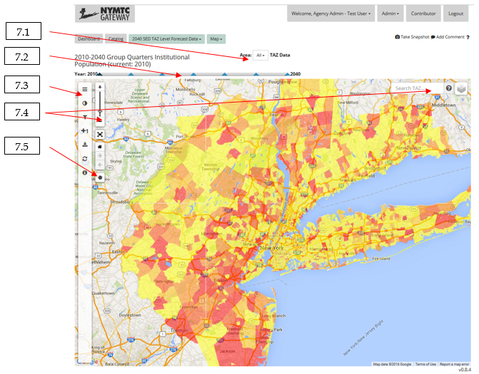

7.1 - Area Selector

7.2 - Other Controls above the Map

7.3 - Sidebar

7.4 - Standard Controls

7.5 - Study Areas

## Area Selector

The Area Selector is found above the Map. It allows you to drill down a specific area as appropriate to the Source and View. It also allows you to access your defined Study Areas from the Map interface.

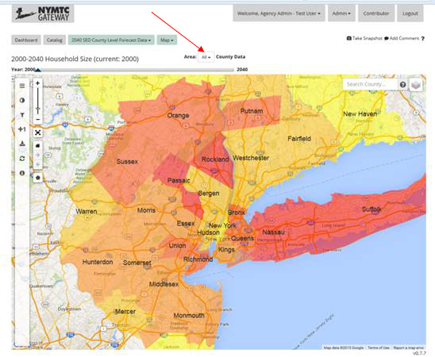

## Other Controls Above Map

### Time Selector

The Time Selector is found above the Map in some Sources and Views. It allows you to drill down a specific timeframe as appropriate to the Source and View. For some Sources and Views it will be years, for others it may be time of day, etc.

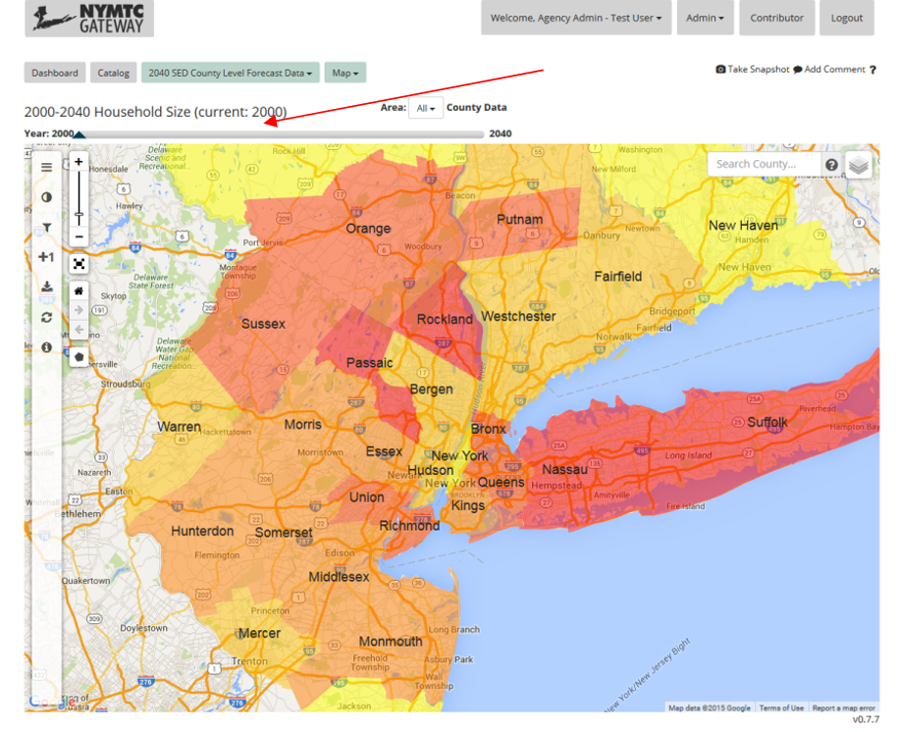

### Measure Selector

The Measure Selector is found above the Map in some Sources and Views that have multiple measures of data that can be visualized. It is labeled by the "Column:" tag.

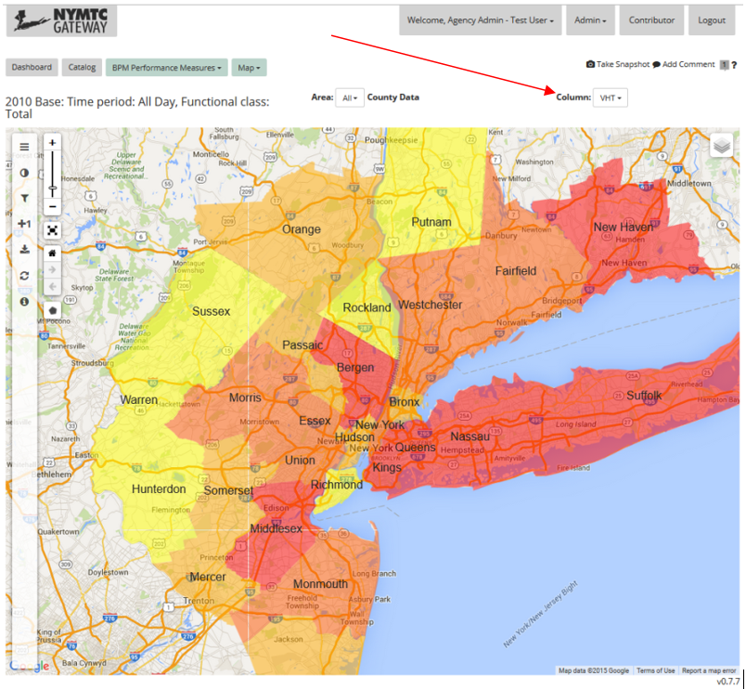

## Sidebar

The sidebar is located on the left side of the Map app. It contains several tools.

### Legends

The Legends tab is located to the left of the Map. For currently displayed layers, it elaborates on symbology displayed on the map. To change symbology, see Styles and Symbology.

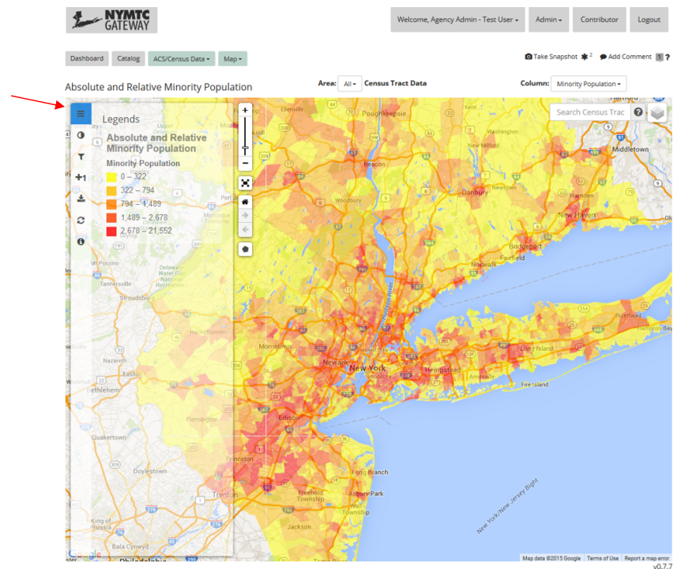

### Styles & Symbology

The Styles and Symbology tab is located to the left of the Map. It allows users to change current map symbology. Users can adjust colors, numbers of bins, etc. depending on the source.

Contributors and Librarians can also save named symbologies for others to use.

You can also save your symbologies to use again or share by creating a snapshot. A snapshot is a "save" of the app in its current state. For more information, see Snapshot.

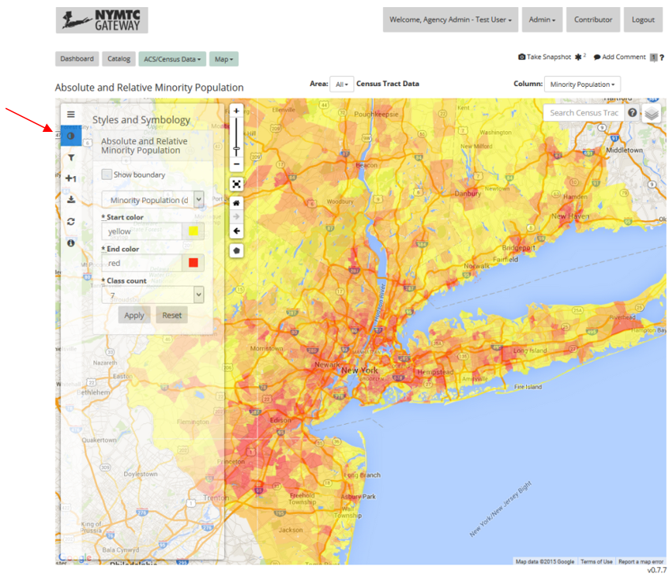

### Filters

The Filters tab is located to the left of the Map. It allows users to adjust what content is being displayed on the map. Available filters depend on view.

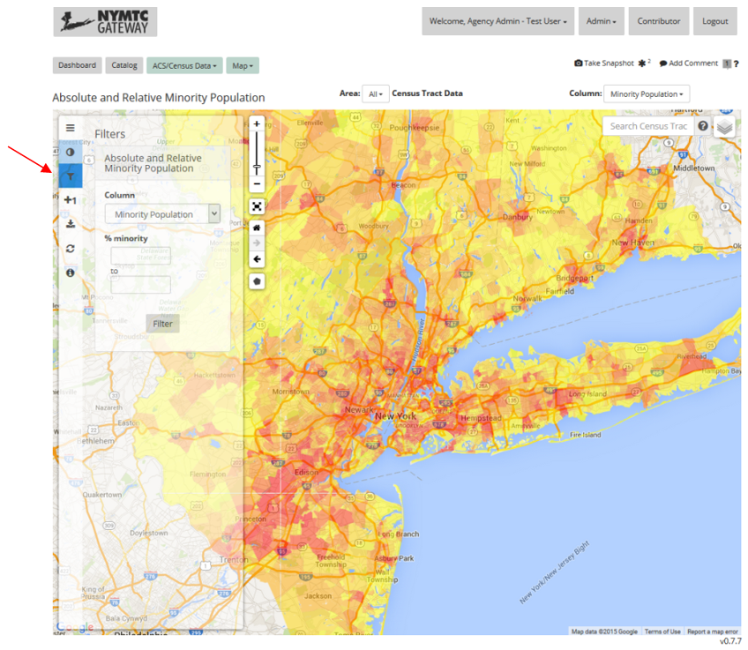

### Add/Remove Layers

The Add/Remove layers tab is located on the left of the map. It allows users to dynamically add and remove data sets from the map. The icon will change to display the current number of layers active.

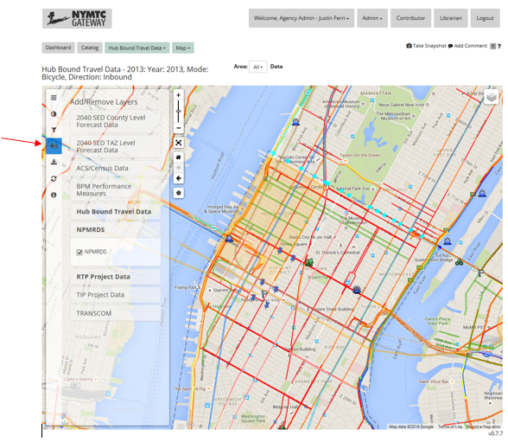

### Export/Download

The Export/Download tab is located to the left of the map. It allows users to export each layer as a shapefile for use external to the Gateway.

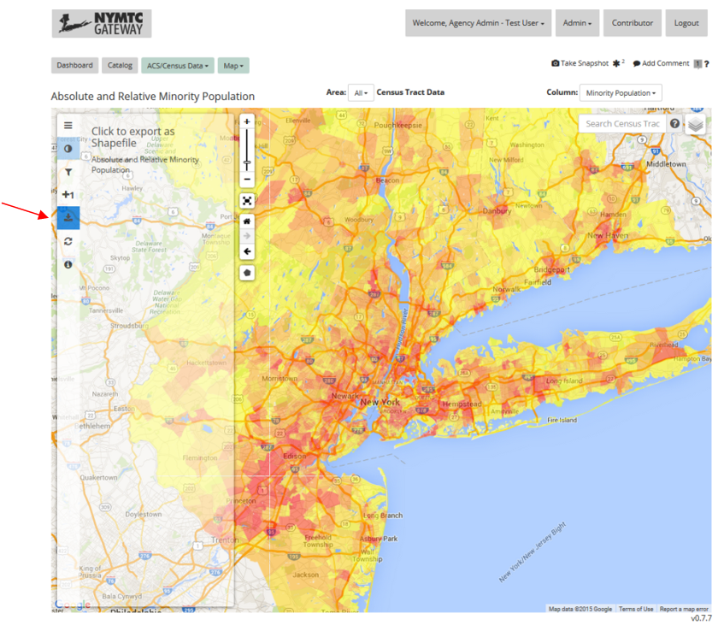

### Restore Default Map

The Restore Default Map button is located to the left of the map. It brings back all the default settings of that specific map per dataset.

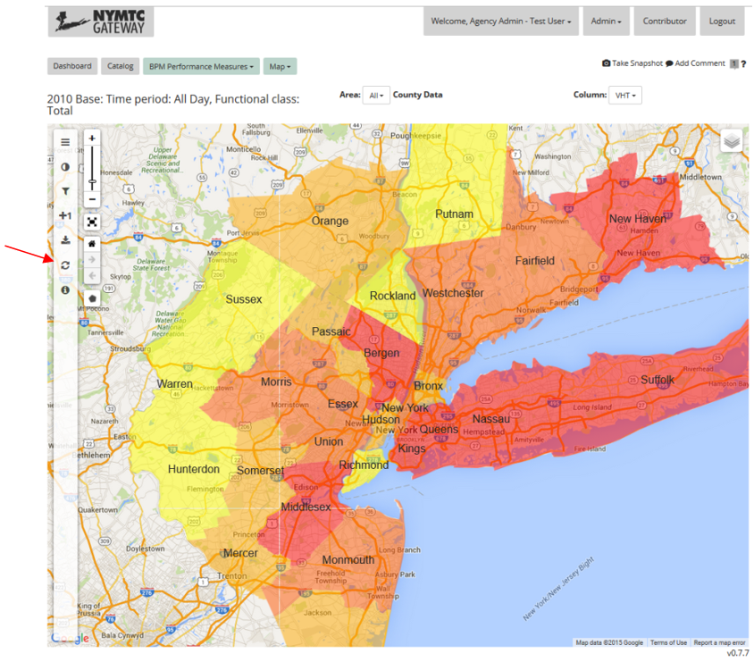

### Attribution

The attribution tab is located to the left of the map. It provides information about the map source and contents as defined in the metadata. For more information on metadata, see Metadata.

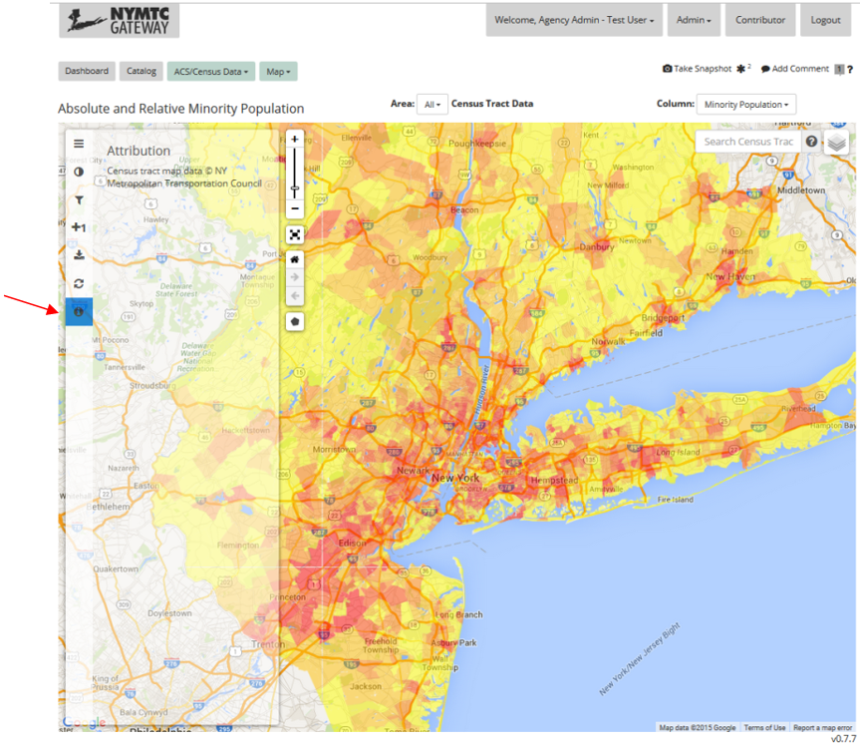

## Standard Controls

### Zoom

The zoom controls allow users to pan in out within the map frame. The plus sign increases zoom, the minus decreases, and the slider in between those two buttons shows the relative zoom level. The slider can be adjusted as well.

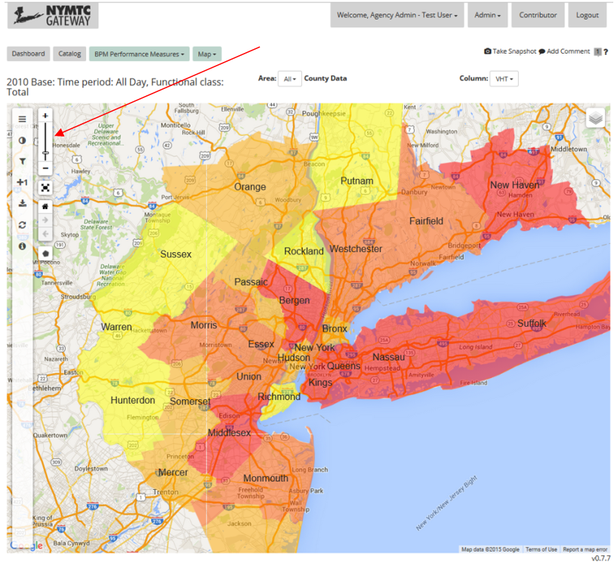

### Full Screen

The full screen button allows the map to assume the entire screen size. Pressing escape will restore the map to normal size.

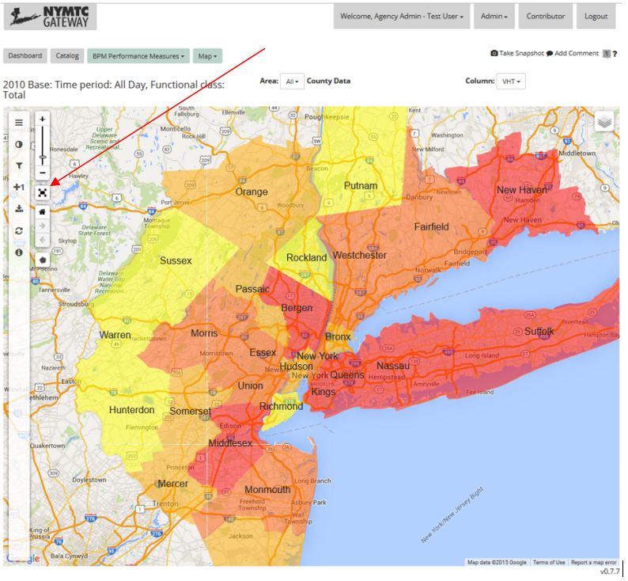

### Home Map View

The Home Map View button re-centers the map view to the default zoom and location.

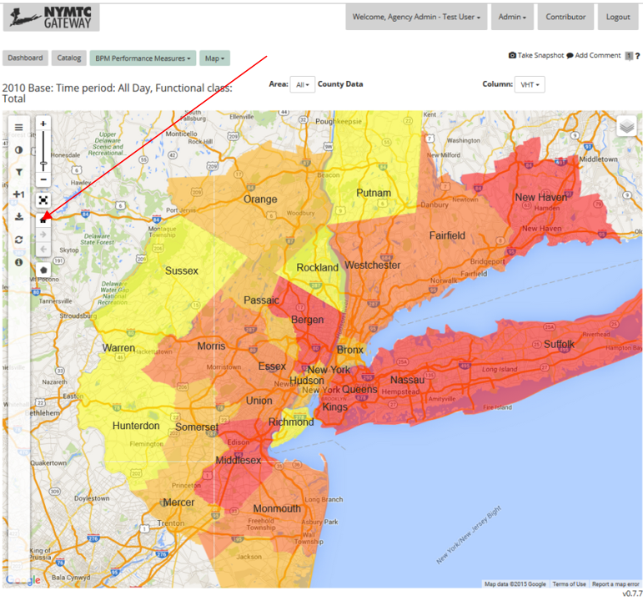

### Map History

The Map History controls let you go back and forth between zoom and location settings. Their control is similar to how a web browser's back and forward buttons work.

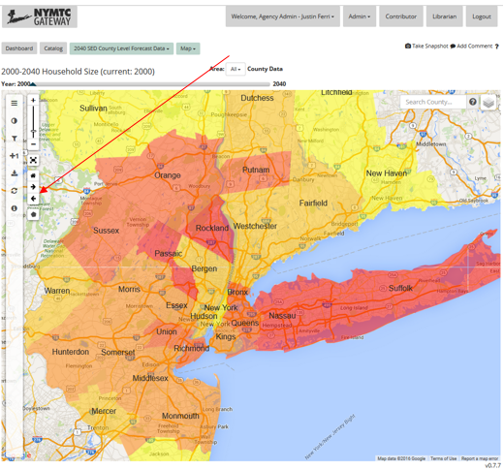

### Search Box

On some maps, a search box will filter for keywords based on dataset. It will zoom and relocate the map accordingly.

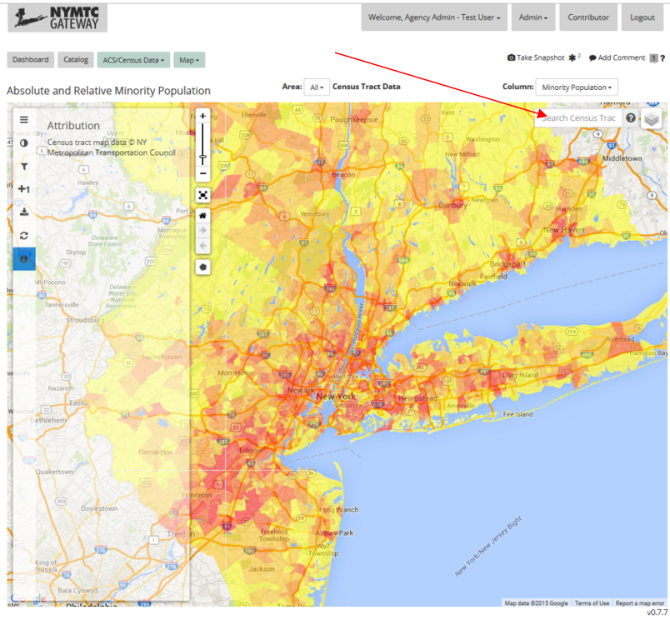

### Layer Control

The Layer Control is located at the top right of the map. Available layers can be turned on and off by checking or unchecking the box next to the layer's name.

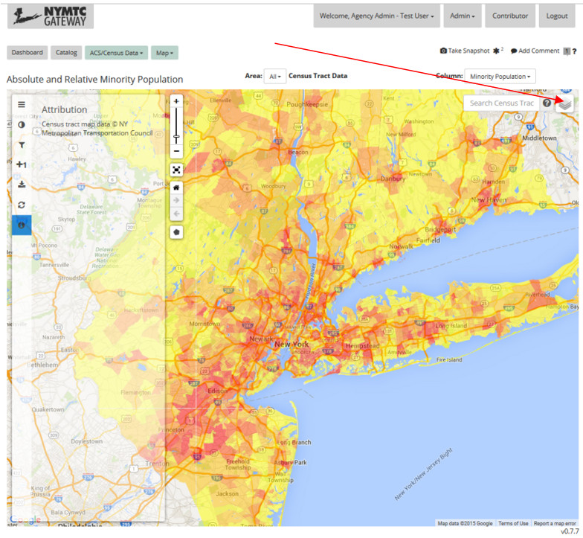

## Study Areas

Study Areas are designed to help you drill down onto specific regional content. To begin defining a study area, click this button on the map.

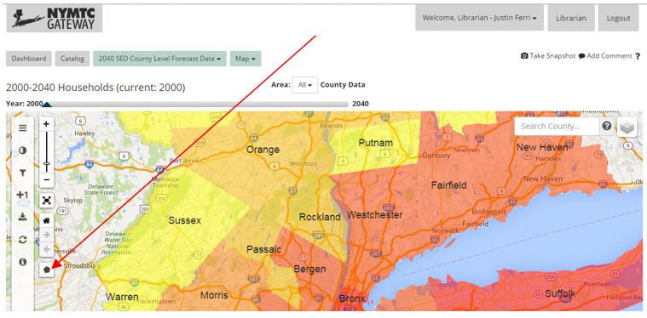

Construct a polygon to define your study area. Click back on the first point to close the shape. There are other controls on the Study Area button to 'Delete last point' and 'cancel.' Study areas lines will include all of any GIS region that their lines intersect with.

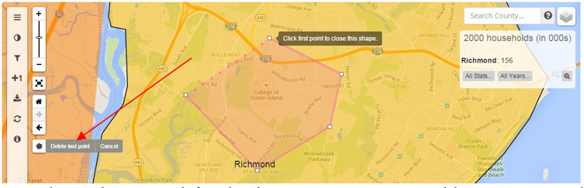

Once the study area is defined, a box emerges to name, add comments, or share the study area.

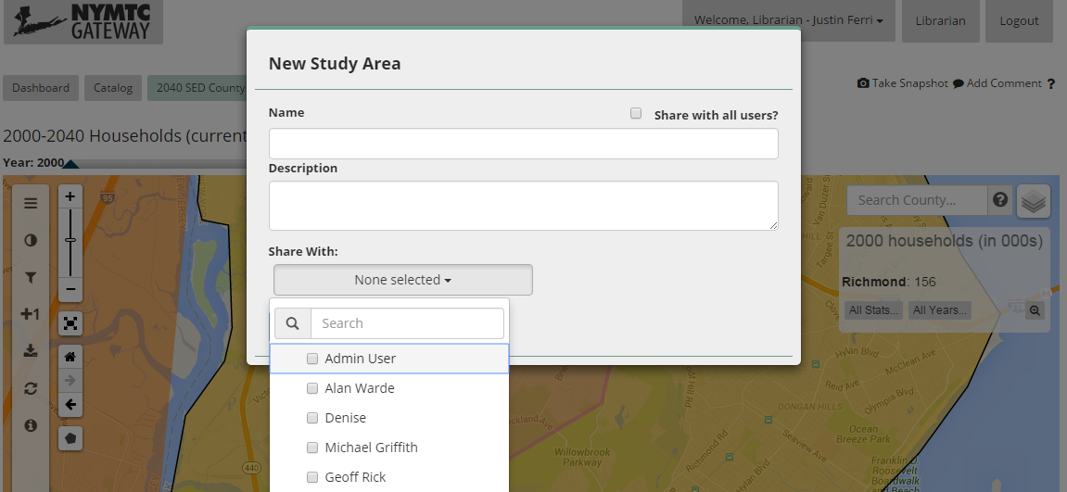

You can select defined study areas (either shared to you by someone else or your own creation) by selecting it under the "area" dropdown. See Area Selector.

You can also access your study areas by clicking "My Study Areas" after clicking on your name at the top of the page. See My Study Areas.

# Tables

## Area Selector

The Area Selector is found above the Table. It allows you to drill down a specific area as appropriate to the Source and View. It also allows you to access your defined Study Areas from the Table interface.

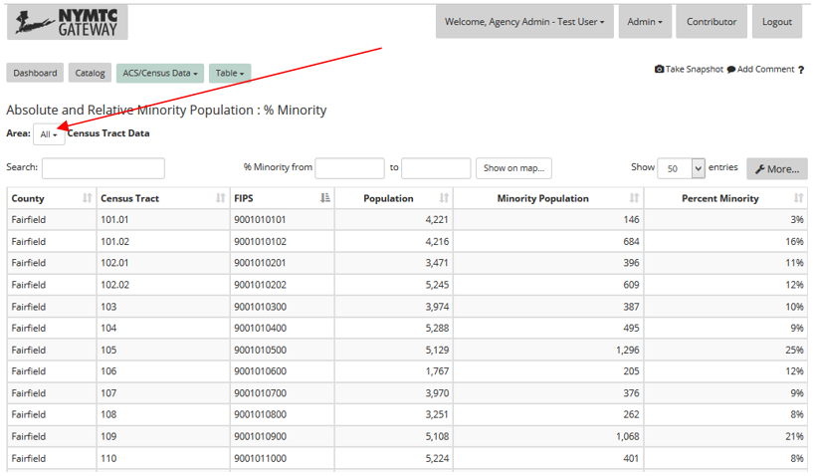

## Additional Controls Above Table

Some datasets will have additional controls above the table. In this example, there is a button that says "Show on Map." This will take the current filtered table and apply those constraints to the map view. This also can be accomplished using the "Breadcrumbs" to the top left of the page. Clicking the green button where it says Table will also show additional Apps that dataset can be viewed in.

There is also a button on this dataset to clear all currently applied filters.

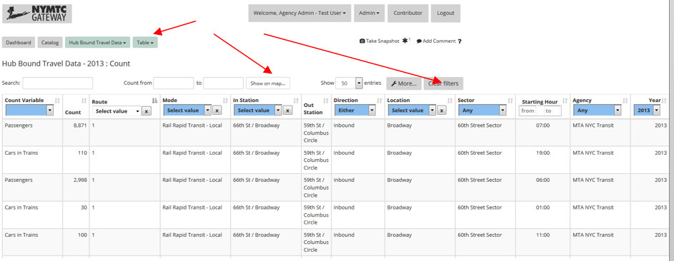

## Table Controls

### Search Box

The search box will filter for alphanumeric strings based on the dataset. It will only display rows containing that string.

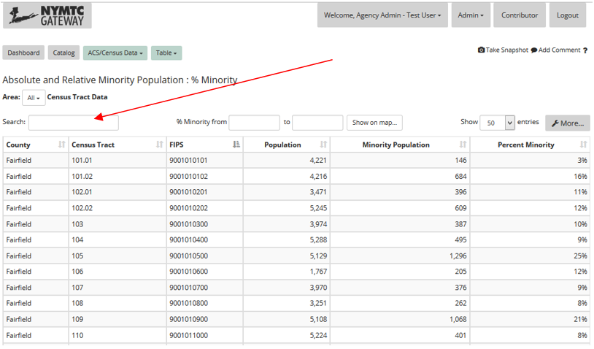

### Range Filters

Range filters allow users to filter the table to contain only rows with a value that falls within the specified range.

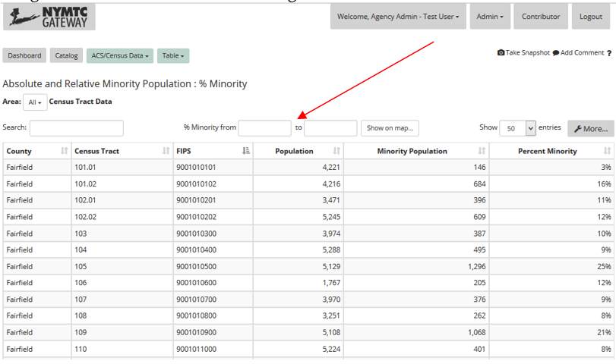

### Number of Entries to Show

This box allows the user to customize how many rows are displayed at a time in the Table.

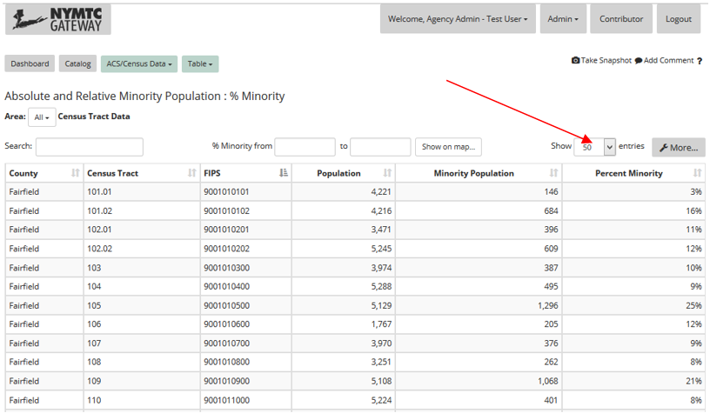

### Column Sorting

Columns can be sorted alphanumerically by clicking the set of antiparallel arrows to the right of each column header. Pressing it once will sort ascending, pressing it a second time will sort descending. Only one column can be sorted at a time, but filters and searches can be applied as well.

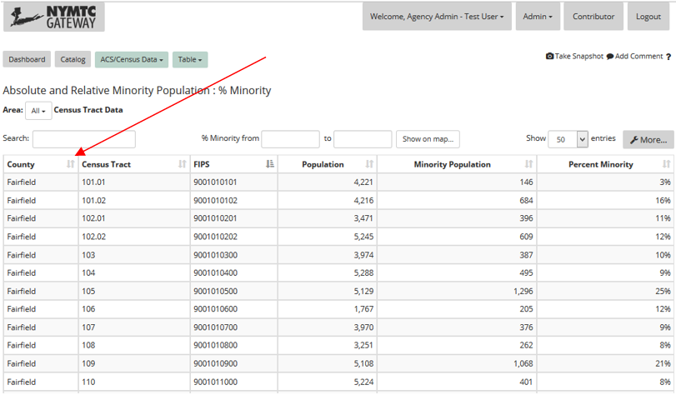

### Column Filtering

In some datasets, columns can be filtered. There will be a dropdown box in the column header where you can select a specific entry to be filtered upon. In this case, each column can have a specific filter (as opposed to sorting, where only one column at a time can be sorted).

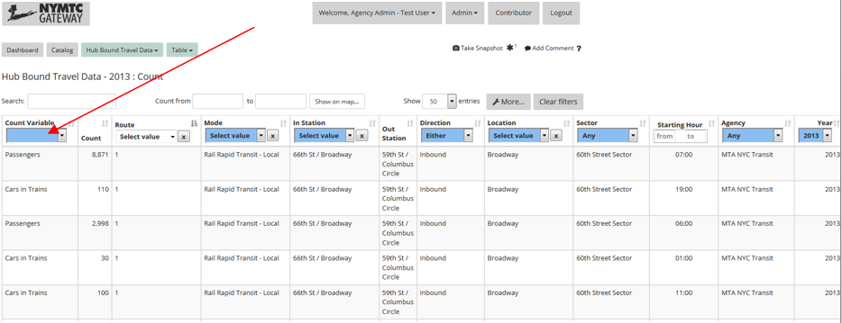

## More…

Clicking the More… button reveals a set of three new options.

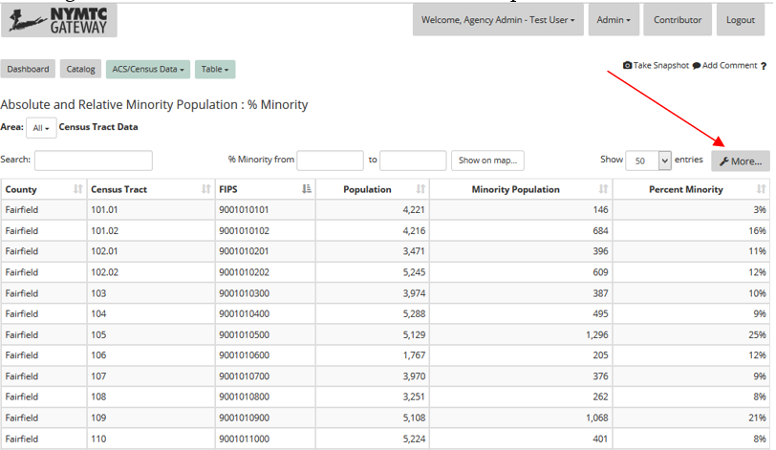

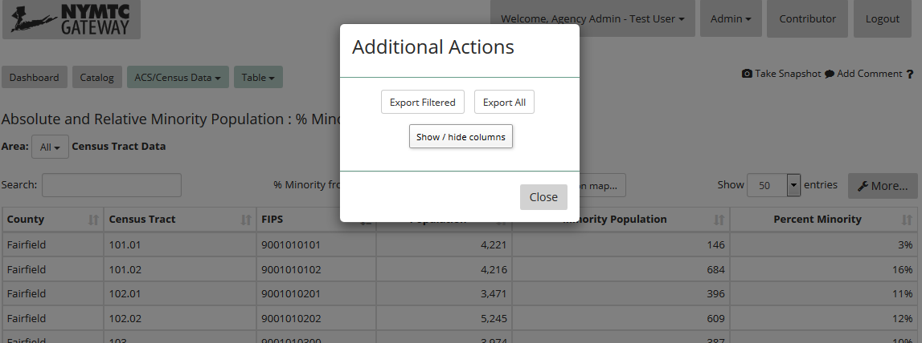

### Export Filtered

This button lets you download a .csv copy of the table, keeping current filters active.

### Export All

This button lets you download a .csv copy of the table, ignoring filters. You will download the entire data set. Note that SpeedFacts datasets, like NPMRDS and TRANSCOM, cannot be exported in their entirety due to size.

### Show / hide columns

If you prefer not to see certain columns at all, you can disable them in the show/hide columns dialog. Columns can be restored by returning to this menu.

# Charts

## Area Selector

The Area Selector is found above the Chart. It allows you to drill down a specific area as appropriate to the Source and View.

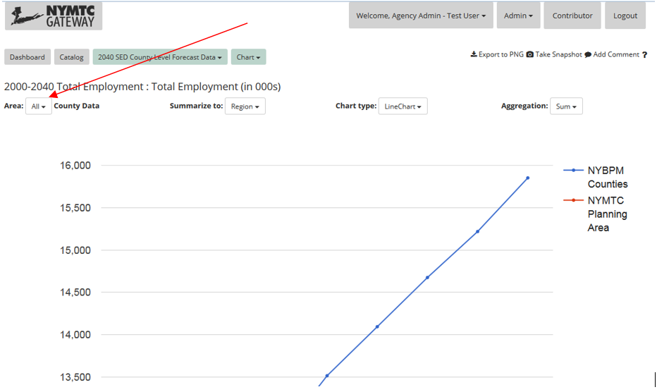

## Summarize To

The Summarize To option allows users to drill down to County, Sub Region, and Region data. These options may be limited based on dataset and other filters applied.

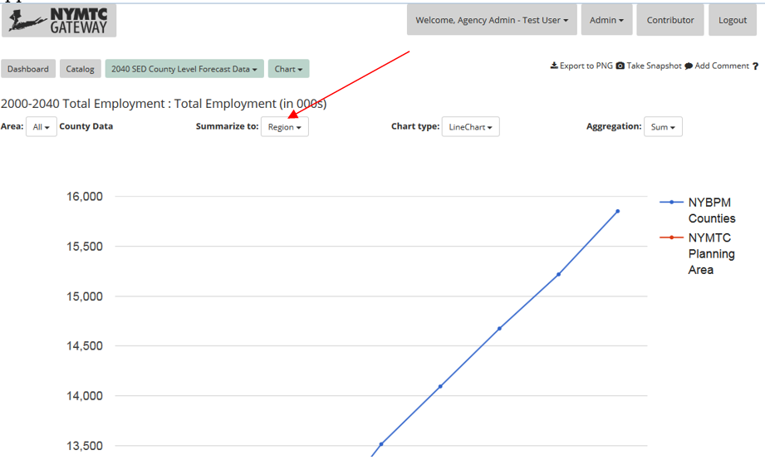

## Chart Type

Charts are available in Line, Area, Bar, and Pie formats. Certain formats may not be available for certain datasets.

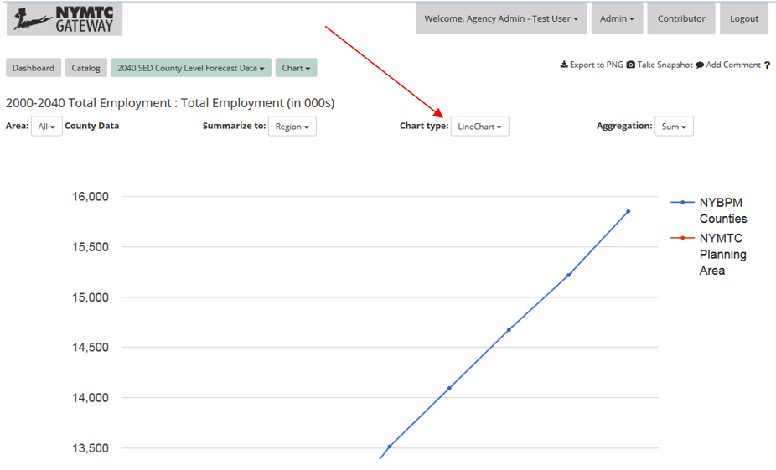

## Aggregation Function

Some Charts can be aggregated by Sum or Average. This can be adjusted with this box.

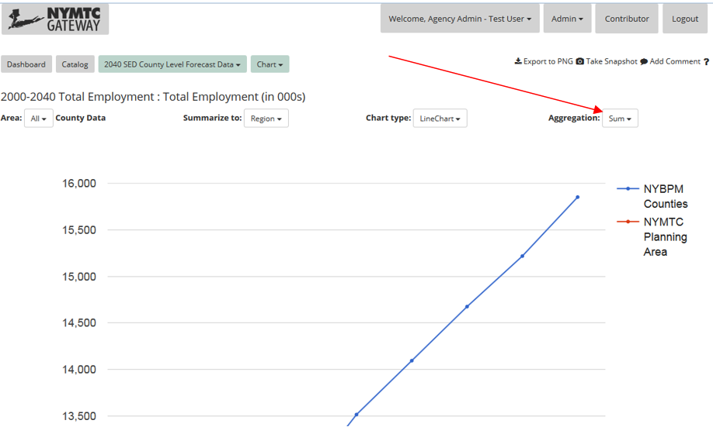

## Other Controls

Some datasets may have additional controls above the chart. These options allow data to be further filtered.

Charts can be exported as PNG graphics or to .CSV files containing the data used to create the chart.

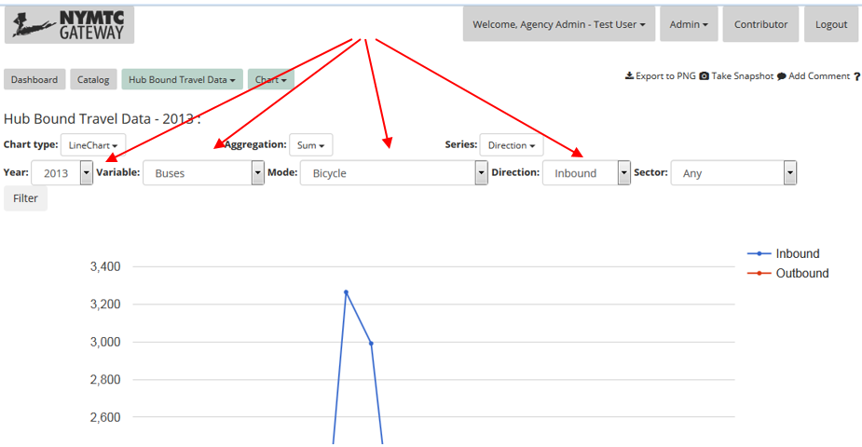

# Snapshots

Registered Users can save a snapshot of the current state of a map, table, or chart so that it can be recalled later without having to reapply filters or other customizable features.

Snapshots are stored for you and can be shared with others during creation.

To create a snapshot, click the "Take Snapshot" button at the top right of a map, table, or chart you've customized. If you have a snapshot (created by you or shared with you) of the specific View and App already, an asterisk will appear next to the "Take Snapshot" with the number of snapshots currently associated with that View and App.

You can view a list of all your snapshots in My Snapshots or on the Dashboard.

# Comments

Registered users can contribute comments on Sources, Views, and in individual Apps. Users can add comments wherever there is a button near the top right navigation menu that says "Add Comment."

Comments you make will be visible to all users unless marked Admin Only.

In the Catalog, you'll see little chat bubbled with numbers in them. This indicates that a user has left a comment on that particular Source, View, or App. You can hover over each icon to see a summary of comments. Clicking the icon will show you all of the comments in full.

## Adding Comments

To add a new comment to a Source in the Catalog, click the arrow to the right of the title. A menu will appear. Click "Add Comment."

To add a new comment to a View in the Catalog, click the View, then click "Add Comment" in the Actions pane that appears.

To add a new comment inside an App, click the "Add Comment" button to the top right of the app, below the top right navigation menu.

In the New Comment window, add a subject (mandatory) and the body of your text. It will appear next to whichever Source, View, or App (shown at the top of the Add Comment window) with a timestamp. If you are an administrator, you have the option to make your comment visible only to other administrators.

# Metadata

Metadata is a collection of information that helps describe a particular Source or View. Metadata can tell you in-depth information about the topic, like who contributed the data, when it was created, when it was last edited, the format of the data, etc.

It can be accessed from the Catalog. Click a particular Source or View, then select View Metadata from the Apps panel.

## Editing Metadata

Metadata can be edited by the Contributor or a Librarian for Sources and Views.

Source Metadata has basic information about the data, as well as some configurable sections for Contributors and Librarians to modify – like assigned agency and default data model. If data is of a standard type, it is admissible to define a default data model. If data will be varied, please leave this option blank.

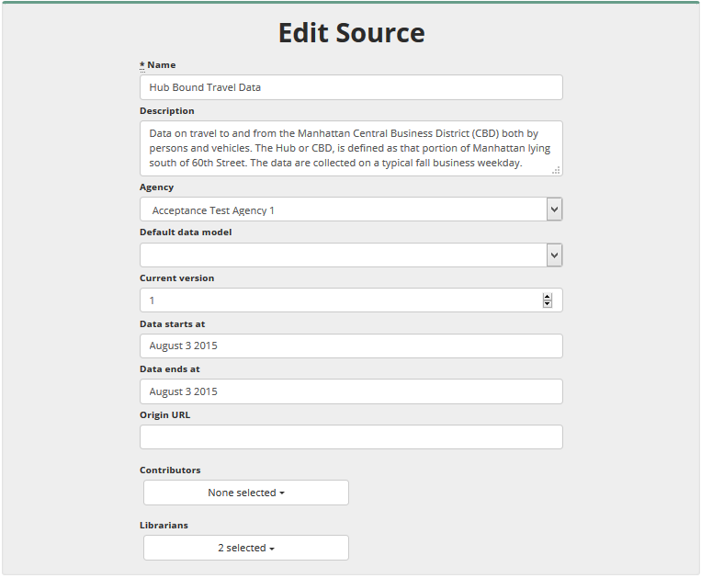

Contributors, Librarians, and Admins can see more information when editing metadata for views. Descriptions follow the screenshot for more complicated options.

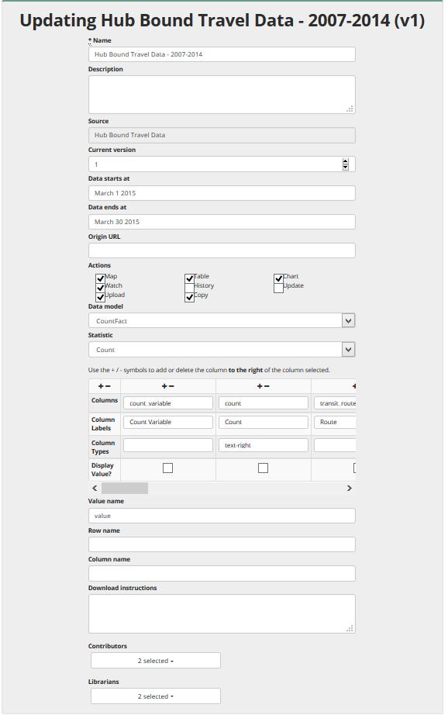

**Actions**: Check which actions users can take after selecting this view.

**Data Model**: This defines which data type the Gateway will store and view the information as. Pick the Data Model that fits your data set (e.g. for TRANSCOM, it will be LinkSpeedFact; for RTP Project Data, it will be RtpProject).

**Statistic**:This defines which statistic the Gateway will use from the specific Source.

**Columns**: This area shows how tables will be defined within the Table app. Add or remove columns to the right of the column with the +/- icon by clicking those buttons. Fill in appropriate information as necessary.

**Value**: Defaults to 'value'

# My Pages

## My Settings

My Settings is available from the header menu at any point by clicking your name, then My Settings.

This page provides levels of customization for many aspects of the Gateway. You can customize your displayed name, change your email address, or change your password. You can change the number of Recent Activities displayed, both the on the Dashboard and when the Recent Activities pane is expanded. You can also change how many of your snapshots are natively displayed.

Saving any changes requires your current password. To reset your password, see Password Reset.

## My Study Areas

You may access your Study Areas at any point by clicking your name, then My Study Areas.

This page provides you with a list of Study Areas, both ones defined by you and ones shared with you. Name, Description, and Status columns can be sorted alphabetically. You can also search in the box in the top right corner for text in any column.

Study areas you've defined may be edited by clicking the icon under the Edit header, and deleted by clicking the icon under the Delete header.

You may not edit or delete Study Areas that were not created by you.

The page defaults to a display of 10 Study Areas, and is available to either scroll through lists of 10 with the controls at the bottom, or viewing more than 10 at a time by adjusting the dropdown box "Show X Entries."

## My Snapshots

You may access your Snapshots at any point by clicking your name, then My Snapshots.

This page provides you with a list of Snapshots, including ones defined by you, ones shared with you, and ones published by others. Name, Description, and Status columns can be sorted alphabetically. You can also search in the box in the top right corner for text in any column.

Snapshots you've defined may be edited by clicking the icon under the Edit header, and deleted by clicking the icon under the Delete header.

You may not edit or delete Snapshots that were not created by you.

The page defaults to a display of 10 Snapshots, and is available to either scroll through lists of 10 with the controls at the bottom, or viewing more than 10 at a time by adjusting the dropdown box "Show X Entries."

## My Comments

You may access your Comments at any point by clicking your name, then My Comments.

This page provides you with a list of your Comments. Subject, Description, Source, View, App, Admin Only Status, Status, and Date Updated columns can be sorted alphanumerically. You can also search in the box in the top right corner for text in any column.

Your Comments may be edited by clicking the icon under the Edit header, and deleted by clicking the icon under the Delete header.

The page defaults to a display of 10 Comments, and is available to either scroll through lists of 10 with the controls at the bottom, or viewing more than 10 at a time by adjusting the dropdown box "Show X Entries."

## What I'm Watching

You may access What I'm Watching at any point by clicking your name, then What I'm Watching.

This page provides you with a list of what you're Watching. You will be notified if any of these sources or view change. Source, View, Last Seen At, and Last Triggered At columns can be sorted alphanumerically. You can also search in the box in the top right corner for text in any column.

Watches you've defined may be deleted by clicking the icon under the Delete header.

The page defaults to a display of 10 Watches, and is available to either scroll through lists of 10 with the controls at the bottom, or viewing more than 10 at a time by adjusting the dropdown box "Show X Entries."

# Contributors

If you are a contributor, you have access to several additional features. These are accessible at any time by clicking the "Contributor" button in the top navigation menu.

The Contributor page is similar to the catalog, but is limited to sources and views for which the user has contributed.

Contributors have access to the following functionality:

* Adding Sources
* Adding Views to Sources they contribute to
* Editing Metadata
* Uploading new data

# Librarians

If you are a Librarian, you have access to several additional features. These are accessible at any time by clicking the "Librarian" button in the top navigation menu.

The Librarian page is similar to the catalog, but is limited to sources and views for which the user has been assigned Librarian

Librarians have access to the following functionality:

* Adding Sources
* Adding Views to Sources they are Librarians to
* Editing Metadata
* Uploading new data
* Processing new uploaded data

# Access Controls

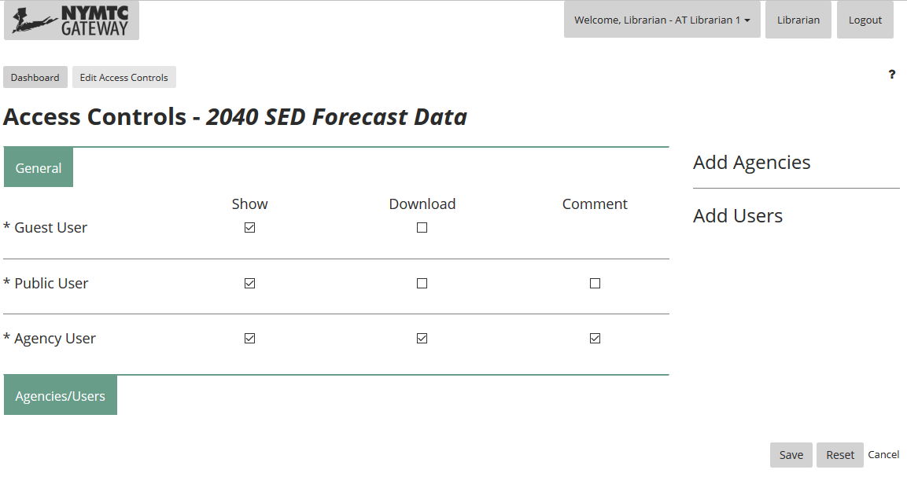

Access Controls allow you to more directly manage what is allowed to be seen/downloaded/commented on, and by whom, in the Gateway application.

Users are grouped in a few ways. In the 'General' section you will find:

* Guest User – someone who visits the application, but does not have an account and is not logged in.
* Public User – someone who has an account and is logged in, but is a base-level user (i.e. is not associated with an Agency/has no special privileges)
* Agency User – someone who has an account, and is assigned to an Agency (as an Admin, User, Contributor, etc.)

By default, the 'Agencies/Users' section will be blank. If you wish to have more granular control over which agencies can see a certain Source or View, click the Add Agencies link on the right-hand side of the page. An entry will be added to the form, and you can modify its settings there.

If you wish to modify the access for a specific agency's user, once you have added the user's agency to the form, you can click on Add Users, then their Agency, and then select the desired user.

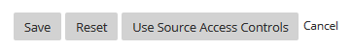

In a view, you will also have an option at the bottom near "Save" to "Use Source Access Controls" – this will make access for that View exactly the same as the Source.

The Reset button allows you to restore default Access Controls.

IMPORTANT NOTES

* Full System Admins cannot be restricted, and thus have constant access to all Sources and Views in the system.
* If a user has multiple roles, the system will give them the abilities of their [most powerful/least restrictive] role. The hierarchy, from most to least powerful, is as follows:

Admin > Agency Admin > Agency User > Contributor > Public

e.g. If a user has the Public, Agency User, and Agency Admin roles, they will be given Agency Admin access.

In almost all cases, more specific settings will override more general settings. HOWEVER, if a Source is not visible/downloadable/commentable, its Views will also not be. You can also prevent a View from being accessed by changing its Access Controls specifically.

# Administration

System Administrators (the highest privilege level) have additional features available. They are accessible from the top navigation menu under the "Admin" button.

## Users

System Administrators may view a list of registered users and perform certain functions for them. This can be accessed at any time clicking the Admin button in the top navigation menu, then Users.

This page provides you with a list of registered users. Name, Email, Agency, Roles, Date Registered, Number of Logins, and Date of Last Login columns can be sorted alphanumerically. You can also search in the box in the top right corner for text in any column.

You may also change individual user roles or delete users.

The page defaults to a display of 10 Users, and is available to either scroll through lists of 10 with the controls at the bottom, or viewing more than 10 at a time by adjusting the dropdown box "Show X Entries."

Clicking on a User will allow you to edit their information.

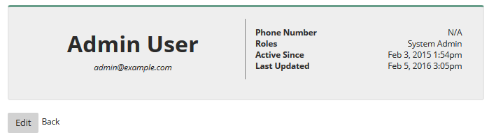

## Agencies

System Administrators may view a list of Agencies and perform certain functions for them. This can be accessed at any time clicking the Admin button in the top navigation menu, then Agencies.

This page provides you with a list of Agencies. Name, Description, URL, Number of Users, and Date Created columns can be sorted alphanumerically. You can also search in the box in the top right corner for text in any column.

You may also add or delete Agencies. To add an Agency, click the New Agency button at the bottom left of the table. To delete an Agency, click the Delete Agency button in the row of the desired Agency.

The page defaults to a display of 10 Agencies, and is available to either scroll through lists of 10 with the controls at the bottom, or viewing more than 10 at a time by adjusting the dropdown box "Show X Entries."

Clicking on an Agency will allow you to edit that Agency, Add Users to that Agency, or Edit Users in that Agency.

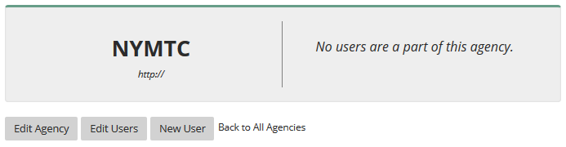

## Comments

System Administrators may view a list of all Comments submitted and perform certain functions on them. This can be accessed at any time clicking the Admin button in the top navigation menu, then All Comments.

This page provides you with a list of All Comments submitted. Subject, Description, User, Source, View, App, Admin Only Status, and Updated Timestamps columns can be sorted alphanumerically. You can also search in the box in the top right corner for text in any column.

You may edit Comments or block them from view except to other System Administrators. To block a Comment, check the box in the "Blocked?" column for the desired comment. To edit a Comment, click the comment Subject, make changes, and save your edits.

The page defaults to a display of 10 Comments, and is available to either scroll through lists of 10 with the controls at the bottom, or viewing more than 10 at a time by adjusting the dropdown box "Show X Entries."

## Uploads

For each View, there is a repository of uploads associated with it. It keeps track of previous versions of the data. If you are a Librarian, Contributor, or System Administrator, you can see the list of uploads in the Metadata, under the Uploads header in the column on the right.

This page provides you with a list of all of the data that has been uploaded for this particular source. You can download the data by clicking their filename. In the status column, you can see whether the data has been uploaded (the status column will say available) or uploaded and processed (the status column will say processed). Data is not live in the Gateway until it is processed. Clicking available will lead you to the processing screen if you are a Librarian or System Administrator. For more information, see Uploading.

The Download File, Size, Status, View, Notes, Month/Year, Uploaded by, and Uploaded at columns can be sorted alphanumerically. The page defaults to a display of 10 Uploads, and is available to either scroll through lists of 10 with the controls at the bottom, or viewing more than 10 at a time by adjusting the dropdown box "Show X Entries."

## Data Recovery

System Administrators may view a list of all deleted Sources and Views in the Data Recovery screen. This can be accessed at any time clicking the Admin button in the top navigation menu, then Data Recovery.

This page provides you with a list of the Sources and Views that have been deleted in the past. Name, Source, Description, and Date Deleted columns can be sorted alphanumerically. You can also search in the box in the top right corner for text in any column.

You may restore any of these data that have been deleted by clicking the "Restore" button in the row of the desired.

The page defaults to a display of 10 Sources and Views, and is available to either scroll through lists of 10 with the controls at the bottom, or viewing more than 10 at a time by adjusting the dropdown box "Show X Entries."

## System Usage Report

System Administrators may view reports about the performance of Users and Data. This can be accessed at any time clicking the Admin button in the top navigation menu, then System Usage Report.

This report is an overall description about total user behavior. It describes which Sources and Views are most popular using various metrics like views, watches, snapshots, comments, downloads, and uploads.

Some segments of this report are hyperlinked.

## System Change Report

System Administrators may view reports about the new content added to the Gateway over a customizable time frame. This can be accessed at any time clicking the Admin button in the top navigation menu, then System Change Report.

This report is a summary of new Users, Agencies, Sources, Views, Uploads, Comments, Snapshots, and Study areas over a user-specified range of time. To change the timeframe, click the dropdown menu and select, Last Week, Last Month, or Custom. Custom timeframes will show you additions since a date specified (using a calendar pop-up).

## User Activity Report

System Administrators may view reports about the activities and content provided by a specific user. This can be accessed at any time clicking the Admin button in the top navigation menu, then User Activity Report.

This report is a summary of specific user information. It shows user privileges, high-level usage statistics, and things like Contributions, Librarian roles, Uploads, Watches, Snapshots, and Comments.

Some segments of this report are hyperlinked.

## Update Help

System administrators can modify the content in this window by uploading a new Gateway Help document. Currently, functionality for replacing images is not supported. The steps to replace text are as follows:

1. Log in to Gateway as Admin.
2. From either All Uploads or "Update Help" download most recent help GatewayHelp.docx file.
3. Edit in MS "Word".
4. Save modified .docx file.
5. File -> Save As -> Browse then in Save As dialog for "Save as type" select "Web Page, Filtered (*.htm, *.html)".
6. In Gateway, select "Update Help" and upload modified .docx file.
7. Select "Update Help" again and upload modified .htm file.

**IMPORTANT NOTES:**

1. Make sure that any 'smart' quotation marks that Word adds are replaced with the standard version – use ' and " in a find/replace to make sure none are included.
2. To allow the website to hyperlink to the correct section of the help document, hover over the "?" on the Gateway page and note the text after the # in the hyperlink. In the Word help document, highlight the section header that will correspond to that page and go to Insert -> Bookmark. Find the text after the # from the hyperlink and select that bookmark. Add a new one if necessary.
3. Changing images is currently not supported without additional assistance.

# Uploading Data

To upload, create and process datasets, you must have contributor and librarian privileges, which can be granted by the owner of the respective datasets or the Gateway Admin.

## 18.1 SED COUNTY AND TAZ

For SED county and TAZ datasets, you will have to create **new SOURCES** for each new year dataset. The steps to create new datasets are as follows:

1. Click on the Main Catalog window or click expand all at the bottom of the main home page.
2. Click on New Source as shown by the red line below.

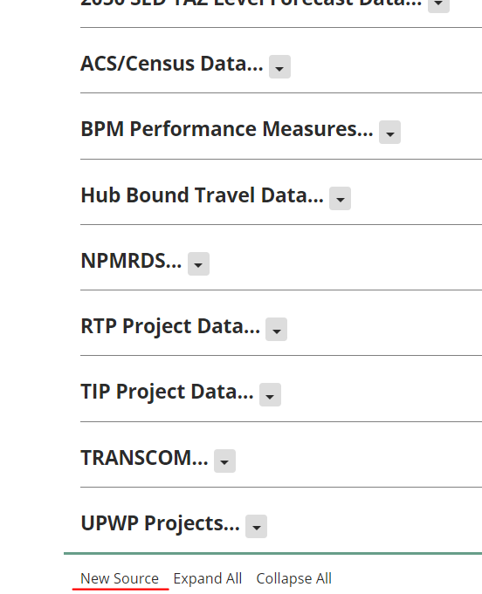

1. Fill in all the details of the new dataset and click save. It will take you to the metadata page.
2. Now you can upload the new dataset to this source. Click on the tab "Contributor" on the top right next to the log in buttons. You will see all the datasets that you have contribution privileges.
3. Click on the Upload option in the dropdown menu of the source that you just created as shown below.

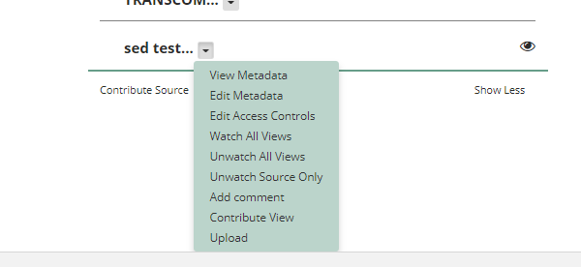

1. Click Upload and in the upload page add the SED csv file. The boundary file is already selected in the Gateway. If there has been an update in the boundary file, you can select from the Area Boundary Base Year option shown below.

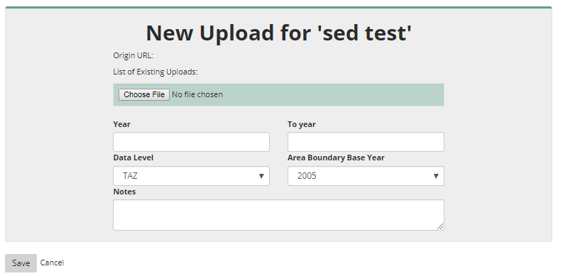

1. Once the upload completes, it will take you to the metadata page from where you can process the file.

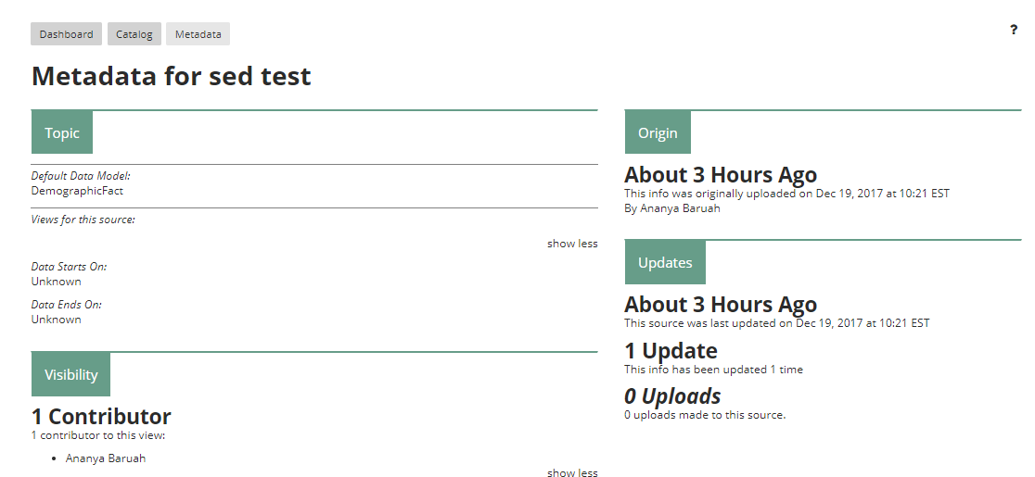

1. From the metadata page, click "Uploads" hyperlink from the Updates section as shown below.

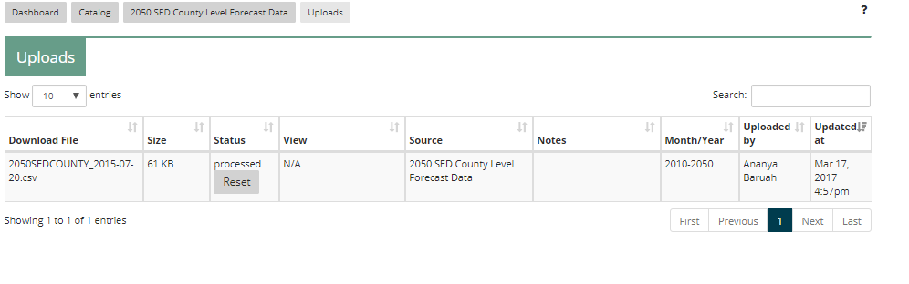

1. In the Uploads page shown below, click Process on the correct file and the new dataset will become available once the processing completes.

**NOTE:** For SED data, this process creates all the new views automatically once the processing completes.

## 18.2 ACS/CENSUS DATA

For ACS datasets, you will first have to download the files from the ACS Census website and then upload to the Gateway.

Each year there are new tables that become available in the ACS website. The two files that are available through the Gateway website are:

1. Absolute and Relative Minority Population Data

2. Absolute and Relative Population Below Poverty Level

## 18.2.1 DOWNLOADING FROM ACS WEBSITE

**Absolute and Relative Minority Population Data (ACS Table id: DP05)**

1. Navigate to:

<http://factfinder.census.gov/faces/tableservices/jsf/pages/productview.xhtml?pid=ACS_13_5YR_DP05&prodType=table>

1. Choose the year for the estimate on the left side.
2. Click "Add/Remove Geographies" at the top to select census tracts for the 31 counties.
3. Select geographic type Census Tract.
4. Start with New York State. Select a <County>, then from the list, select "All Census Tracts within <County>, New York".

For New York, the county list is:   
Bronx   
Dutchess   
Kings   
Nassau   
New York   
Orange   
Putnam   
Queens   
Richmond   
Rockland   
Suffolk   
Sullivan   
Ulster   
Westchester

For Connecticut:   
Fairfield   
Litchfield   
New Haven

For New Jersey:   
Bergen   
Essex   
Hudson   
Hunterdon   
Mercer   
Middlesex   
Monmouth   
Morris   
Ocean   
Passaic   
Somerset   
Sussex   
Union   
Warren

1. Then click Show Table. Then Modify Table.
2. You will need to reduce the rows to just **Race: Total Population and Race: White**. Collapse as many rows as possible, then deselect all but those two rows.
3. Finally, click Transpose Rows/Columns. Now you should be able to download the table as CSV. Click on the Download link at the top. In the dialog that comes up, select "Data and annotations in separate files" and make sure that "Include descriptive data element names" is unchecked.
4. You will need to check the downloaded file to confirm that the column headers match and possibly edit them if necessary. The second column must be "Id2" and the third "Geography". The column headers should also include "HC01_VC77", corresponding to "Total population", and "HC01_VC78", corresponding to "White".

**Absolute and Relative Minority Population Below Poverty Level (ACS Table id: S1701)**

1. Navigate to:  <https://factfinder.census.gov/faces/tableservices/jsf/pages/productview.xhtml?pid=ACS_15_1YR_S1701&prodType=table>
2. Select a year for the estimate on the left side in the box labeled "Versions of this table are available for the following years:"
3. In the Actions menu near the top, click "Add/Remove Geographies" to select census tracts for the 31 counties included in the Gateway .
4. In the Add/Remove Geographies window that appears, in the white box on the left, under "Select a geographic type:" select "Census Tract" .
5. You'll then need to select different states and counties, as detailed below:
6. For New York, it will need to be done by county. Select New York in the state dropdown, then in the County dropdown, select Bronx County, then below select "All Census Tracts within Bronx County, New York then click "Add to your Selections." You'll see that selection appear in the box on the right side of this window.

For New York, add all Census Tracts for the following counties: Bronx, Dutchess, Kings, Nassau, New York, Orange, Putnam, Queens, Richmond, Rockland, Suffolk, Sullivan, Ulster, and Westchester.

Follow the same steps for Connecticut, add all Census Tracts for the following counties: Fairfield  Litchfield  New Haven.

For New Jersey, repeat the above process for the following counties:  Bergen  Essex  Hudson  Hunterdon  Mercer  Middlesex  Monmouth  Morris  Ocean  Passaic  Somerset  Sussex.

1. Once you've finished adding Census Tracts, on the right side, below the "Your Geography Selections" box, click Show Table.
2. Once the table appears, click Modify Table on the actions menu near the top .
3. We now have to condense the table so that it will only give us data we need for the Gateway. For this data set, it is only the top row, called "Population for whom poverty status is determined".
4. To reduce the amount of data needed to be exported, click the minus icon to the left side of every category, and when those are all gone, uncheck the check box next to every row that isn't "Population for whom poverty status is determined".
5. Next, under the table tools menu near the top, click "Transpose Rows/Columns". In the actions menu near the top, click "Download".
6. In the window that appears, select "Data and annotations in separate files" and uncheck "Include descriptive data element names" then click OK.
7. When the file has been prepared, click Download.
8. You will be provided with a .zip file. Inside the .zip, the spreadsheet we need is the .csv file listed first (it is also the largest in size).
9. Extract that file and open it. We will need to edit some column headers and make sure the right data is present.
10. The header in Column B will need to be changed to exactly Id2 . The header in Column C will need to be changed to exactly Geography.
11. Look to make sure that there exists columns HC01_EST_VC01 and HC02_EST_VC01.

**NOTE: For the Geography selection part in the above two sections, there is already a filter saved that can be used to speed up the county and census tract selection process. In the navigation pages provided for each of the ACS datasets, follow the steps below to select the counties and then do a search by the table ID provided in the above steps.**

Go to: <https://factfinder.census.gov/faces/nav/jsf/pages/searchresults.xhtml?refresh=t>

In the load search menu on the left side of the page (shown below), load the file "ACS save.aff".

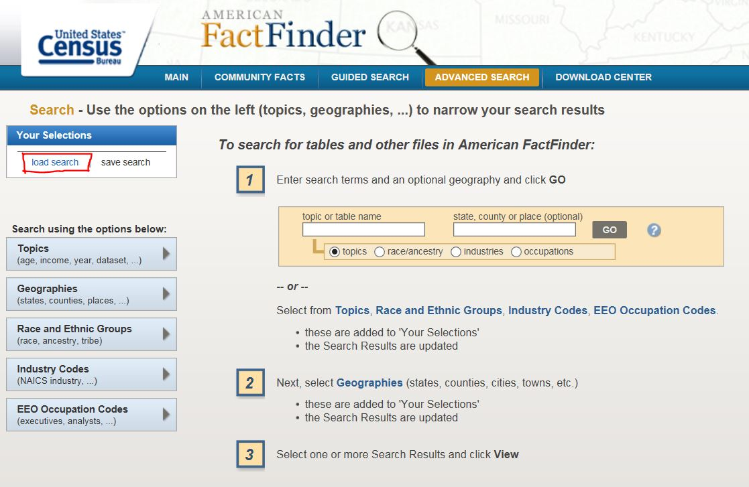

Once the file is loaded, it will select the geography area and will take you to the table download page as shown below. Type in the Table ID (eg. S1701) in the logic or table name field and click on the appropriate table.

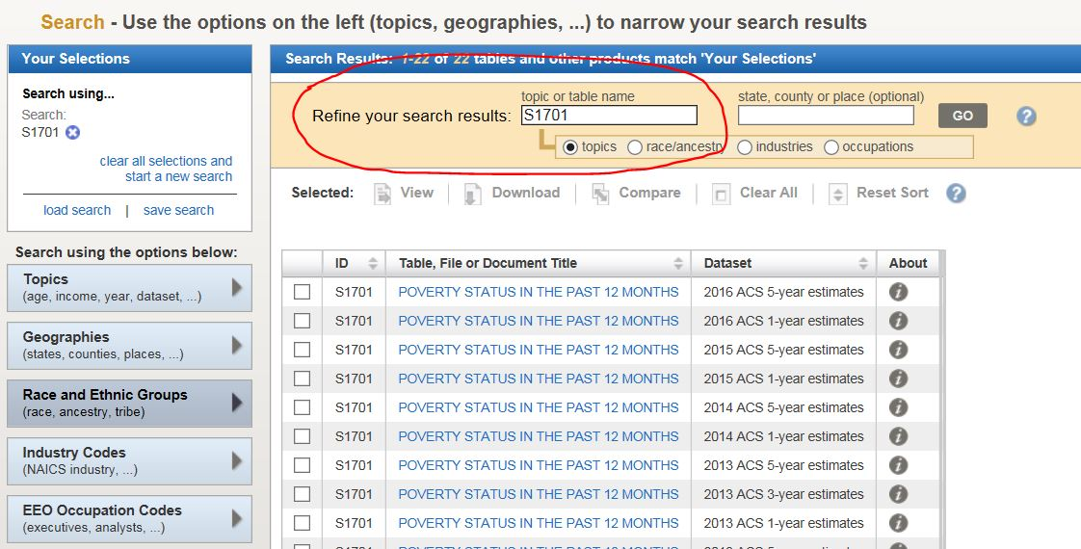

From this point follow the steps from "Modify Table" outlined in each of the ACS file download section above.

## 18.2.1 UPLOADING AND PROCESSING IN THE GATEWAY

To upload new datasets, you will have to create new views for the ACS datasets.

1. Click on a view for which you want to create a new data view.
2. Click Copy from the Action items on the right
3. Fill all the mandatory spaces in the new view as shown below. Give the view a new name similar to the one you copied. Click save and it will take you to the metadata page.

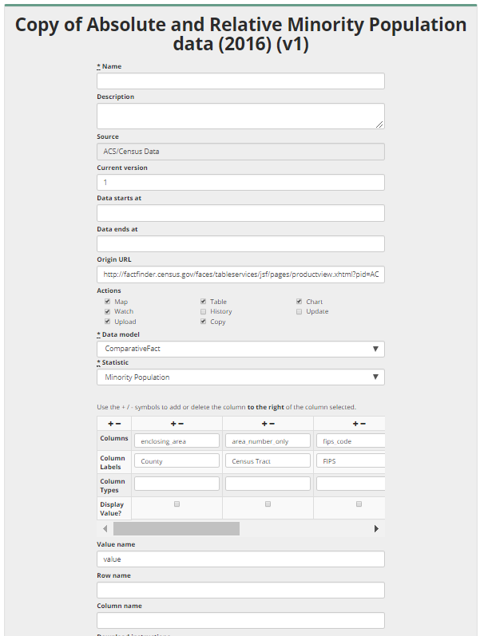

1. You can now upload the files either through the metadata page or the main catalog page.
2. In the Catalog page, click on the new view you just created and click upload from the Action items.

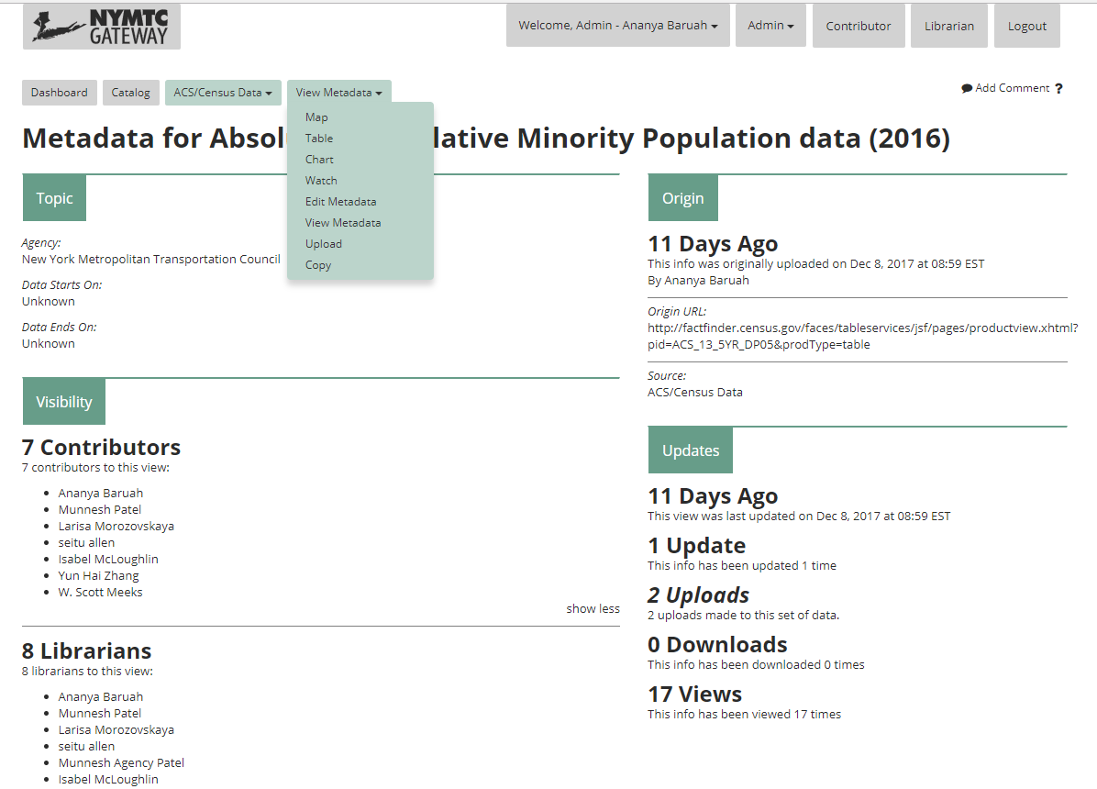

1. From the metadata page, click upload from the dropdown option on the top menu bar under "View Metadata" as shown below.



1. Click Upload and upload the appropriate csv file, enter the required information in the upload page and click save.
2. The new upload can now be viewed from the "Updates" section in the metadata page.
3. Click on the "Uploads" link under the Updates section and it will take you to a page with all the uploads made to this new view.
4. Click Process on the correct file and the new dataset will become available once the processing completes.
5. Repeat this process for the two ACS files downloaded from the ACS website.

## 18.3 RTP AND TIP DATA

For RTP and TIP datasets, the process is similar to creating new views and uploading new files. Prior to creating new views on TIG, zip the item shapefiles into one file (point, line and polygon shapefiles into one zip file for each TIP and RTP). The steps to upload into Gateway are outlined below:

1. Click on a view for which you want to create a new data view. Click Copy from the Action items on the right.
2. Fill all the mandatory spaces in the new view as shown below. Give the view a new name similar to the one you copied.

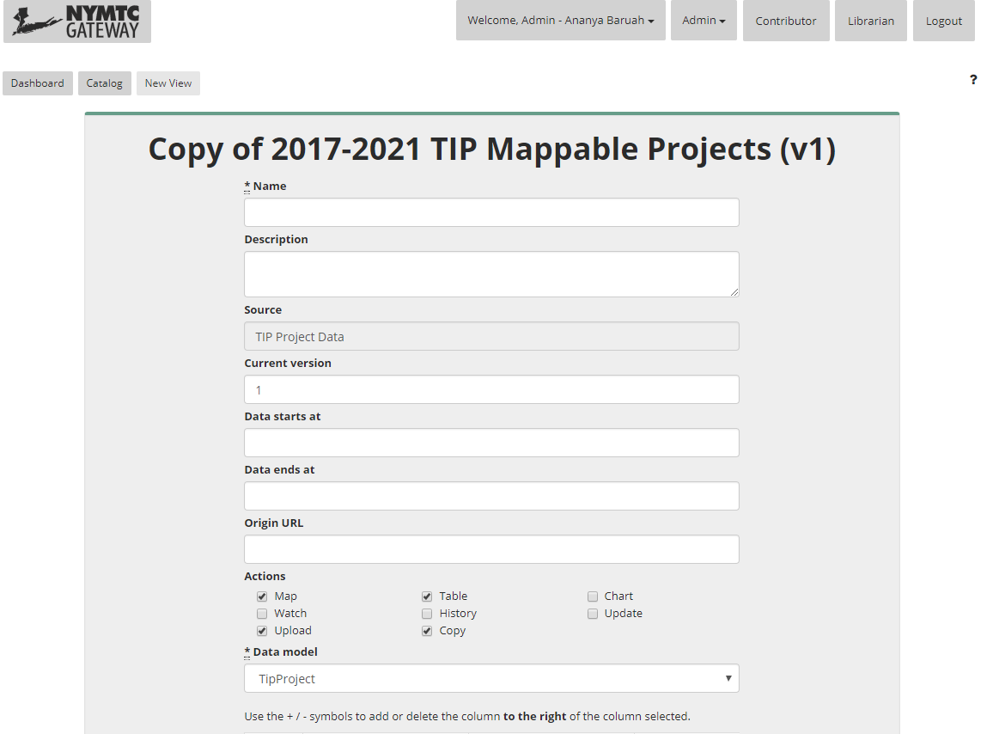

1. Click save and it will take you to the metadata page. You can now upload the files either through the metadata page or the main catalog page.
2. In the Catalog page, click on the new view you just created and click upload from the Action items.
3. From the metadata page, click upload from the dropdown option on the top menu bar under "View Metadata" as shown below.

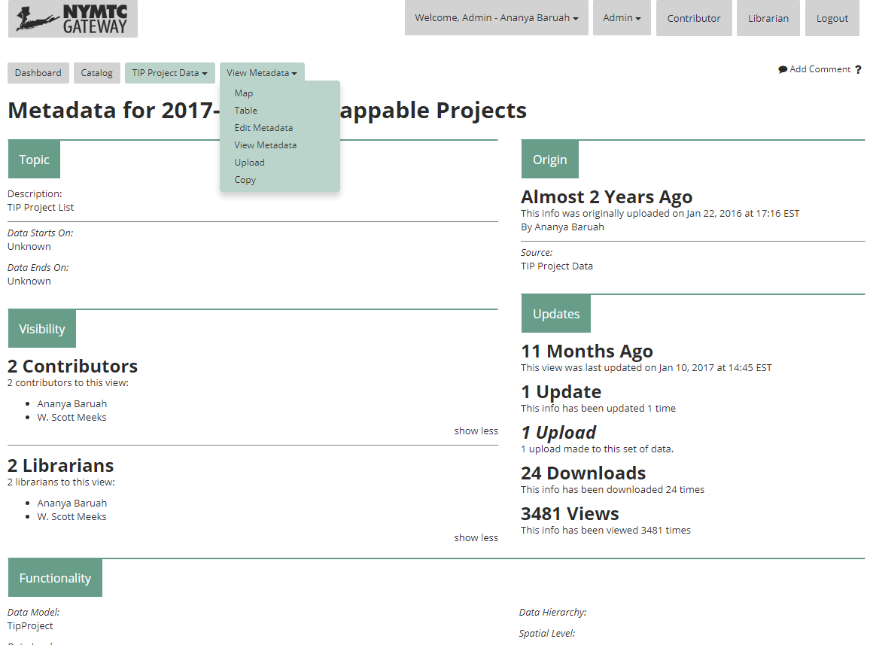

1. Click Upload and upload the appropriate zip file (zipped shapefiles), enter the required information in the upload page and click save.
2. The new upload can now be viewed from the "Updates" section in the metadata page as shown below.



1. Click on the "Upload" tab and it will take you to a page with all the uploads made to this new view. Click **Process** on the correct file and the new dataset will become available once the processing completes.

## 18.4 HUB-BOUND/NPMRDS/TRANSCOM DATA SETS

The Hub Bound dataset is an annual dataset and can be uploaded only once a year. NPMRDS and TRANSCOM datasets are monthly datasets which can be processed and uploaded every three months. The steps to upload these datasets into Gateway are outlined below:

1. Click on the respective view for which you want to upload a new dataset.
2. Click on Upload from the Action items on the right.
3. Upload the csv/zip file (for NPMRDS and TRANSCOM) and access database (for Hub Bound), enter the year/month and Notes for the dataset as shown below and click save.

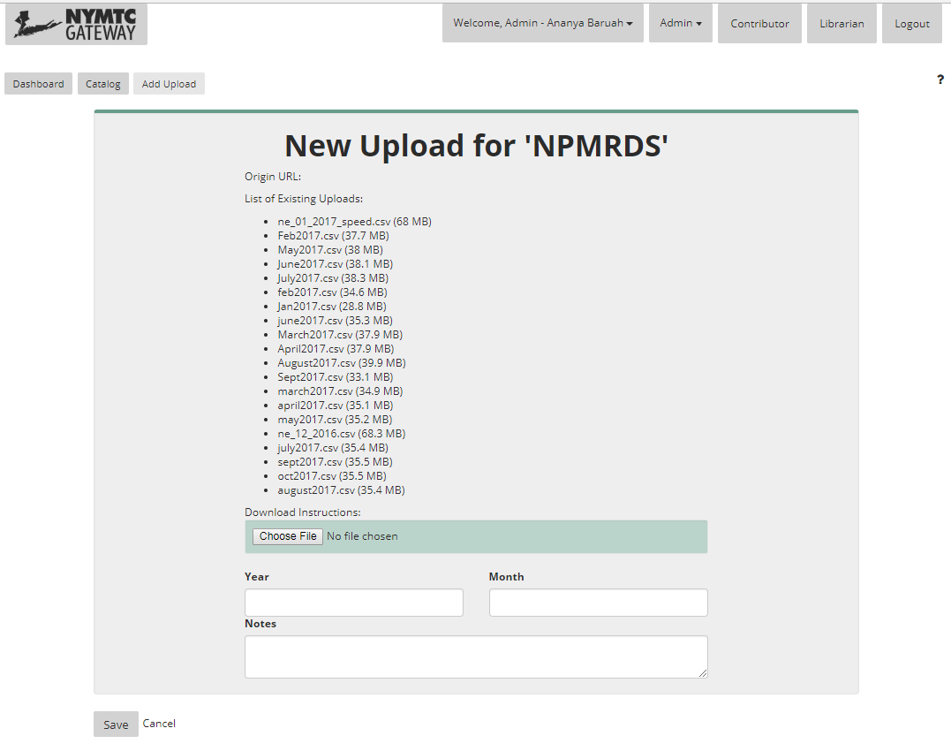

1. Once uploaded, it will take you to the metadata page where you can go to the Updates section and click on "Uploads" hyperlink.
2. In the Uploads page, click "Process" on the most recent file that you just uploaded. You can also sort the datasets by the "Updated at" field in the table to get the most recent uploaded file.

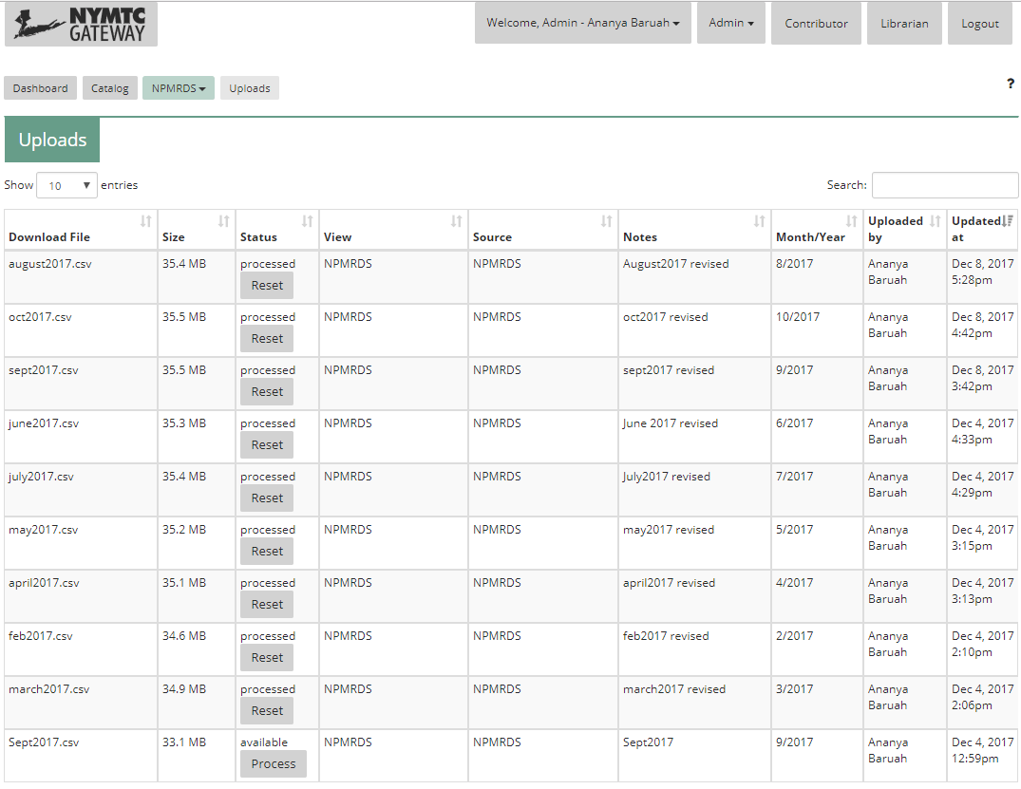

1. You can view the progress bar by clicking on the "Process"/ "Processing" hyperlink in the upload page and it will take you to another page where you can view the processing progress bar.

# Frequently Asked Questions

## Why can't I see sources or views on the dashboard?

Are you logged in? Guest users (users who are not logged in) have limited access to Sources and Views. Either log in or sign up for an account.

If you are already logged in, but can't see any Sources or Views, or can't find one that you believe you have access to, contact your agency administrator. Agency administrators have control over which users and agencies can see Sources and Views that they contribute to the Gateway.

## Why am I having trouble seeing Gateway content?

The Gateway only supports modern web browsers. Please contact your IT Staff to determine if your browser is recent enough to view HTML5 content. The Gateway will not function correctly with IE9 and prior.

## Is there data for <Insert Region> in the gateway?

Agency Administrators provide data to those that they find qualified to view it. If there's a specific region in the NYMTC area whose data you'd like to see, please contact their agency administrator.

## When I switch between Sources, Views, and Apps, my filters persists. Why?

Where applicable, filters carry through to different applications, sources, and views. We expect users to generally want to be looking at similar data subsets within the same general time span. Remembering filter settings is generally considered more useful than requiring the user to set the filters up again every time they navigate to a different view.

## How do Study Area borders intersect with GIS borders?

Study area lines that intersect with GIS borders are inclusive – they will include all of the data for any delineation they intersect.

## Why do NPMRDS and TRANSCOM data take a long time to process?

These data sets in particular are very large. Mapping, tabularizing, or charting them takes a considerable amount of resources. Exporting, uploading, and processing them will also take a considerable amount of time.